Design Portfolio
201909224
COMM1790

Assignment 1A
Logo and Style Guides

The logo

Format: SVG
Software: Illustrator
Color: ac1927

Brand Identity

Mariam Fashion is a clothing store in Leeds that I found on leedscompany.co.uk. They have a Facebook page but no website.

The old brand logo wasn’t welcoming for the community to shop there, so a change was made, and the new logo allowed the shop to look more intriguing and inviting. The high heel adds dimension to the name since ‘fashion’ is often portrayed as a feminine category, and what more than a high heel to saturate that idea.

Logo versions

During a print, the logo should be monotone, so I created two versions of the logo to be used on either white or black backgrounds



Logo position

The logo could be placed in the center or any of the corners if needed.



Typography

I substituted the logo font to ‘Athelas’
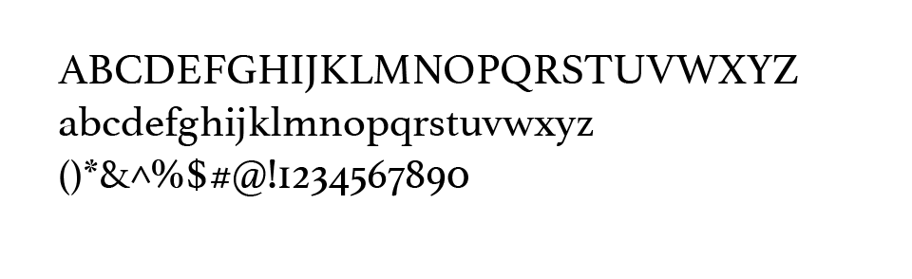

Assignment 1B
I decided to use peace and conflict as my social change project to advocate for the people who cannot.

Assignment 1C



Sometimes, during your lifetime, you find yourself geographically separated from your friends and family, and all you would like to have is them in front of your eyes and communicating like normal. While there are apps that provide ways to communicate with one another, such as Facetime or Skype, these apps only provide temporary and brief pleasure as you are limited to what you see on the screen. However, with the rise in technology that we are seeing and the rapid advances in the virtual environment, in the next 15 years, I envision a time when we are able to see our loved ones directly in front of us as a whole. This can occur when you call a friend on your phone, and a virtual hologram of that person appears in front of you where you and your friend can share simple experiences, whether it is watching the same movie, doing arts and crafts, or simply just catching up all with the added pleasure of having them right alongside you instead of being confined and limited to a small screen.

https://media.istockphoto.com/id/1311088144/photo/excited-black-african-american-man-having-a-video-call-on-smartphone-while-sitting-on-a-sofa.jpg?s=612x612&w=0&k=20&c=cOEIGI86M9rf-o23BmT3NvFUTvWBLv_nCB-ijcGyVM4=

ASSIGNMENT 1D



Posters

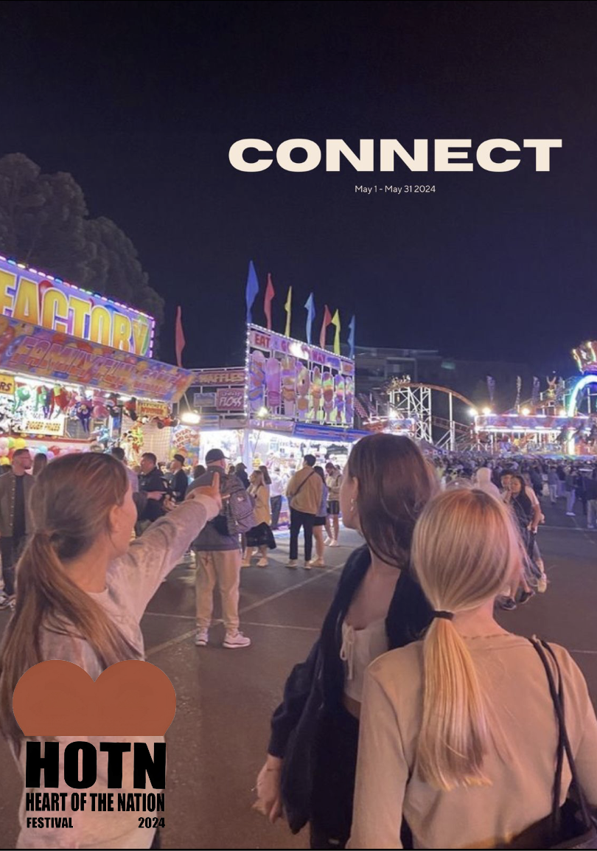
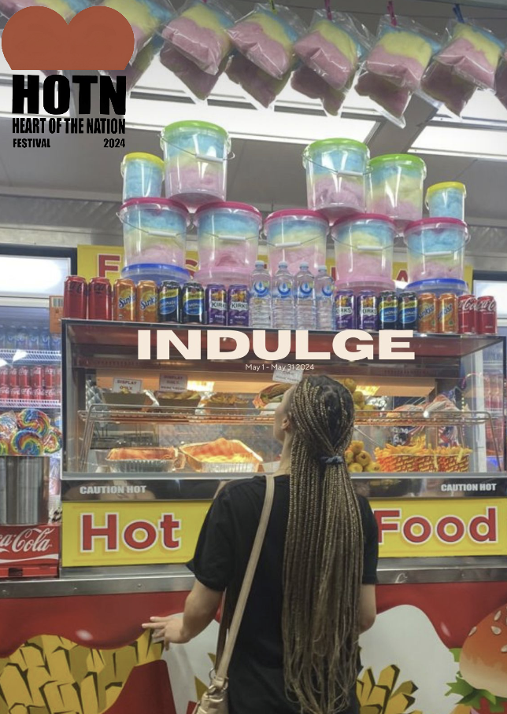
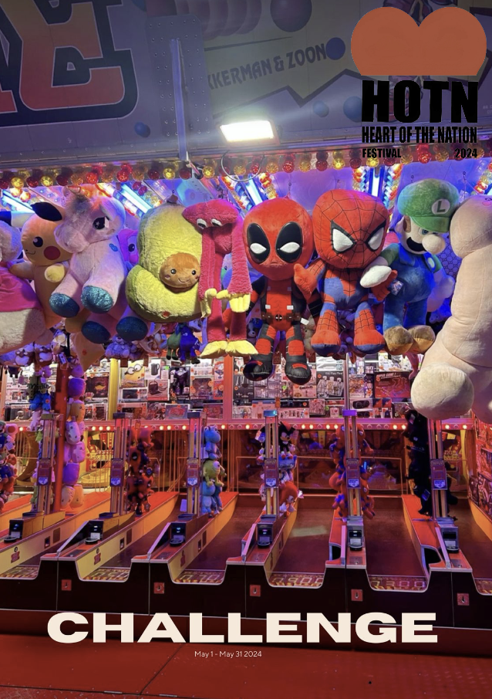
Admission tickets
